Server Side Development Project

# Shoe Shopping Website

Contents

Shoe Shopping Website 1

The name of the database 3

The name of the sql file 3

Project Brief 4

Component Elements 5

Select 5

Delete 7

Insert 8

View of database 10

Customer: 10

Item: 10

Itemstock: 11

Orders: 11

# The name of the database

minimalist

# The name of the sql file

minimalist.sql

# Project Brief

This server side development project is to simulate a real-life shopping website to buy shoe online. In this project a customer allowed to view all the item and all its available size. A customer can only buy one item with maximum quantity of 3 in this project. Before checking out, a customer must be registered and sign in to the website. A customer id, item details will be stored in session and will be used during check out process. After buying a product, a customer is able to check if the order is pending deliver or delivered. A customer can change his/her own details and can log out from the session at anytime.

As a shop administrator, he is able to check all the item stock, add stock, change the order status, and remove the item.

# Component Elements

## Select

In each selling item, all the available size will list out by using select

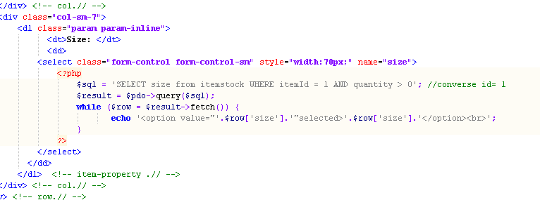

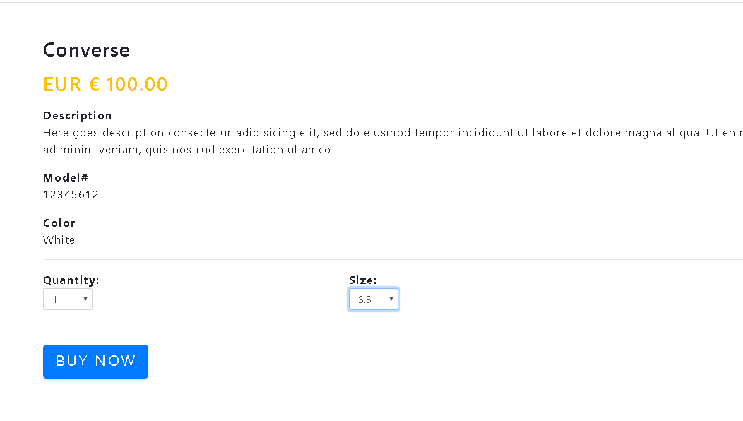

In this case an item named Converse with itemId 1.

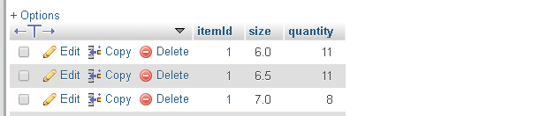

## Delete

An administrator able to delete a item stock in the website.

Before: show all the available chosen item and all the Adidas Ultraboost item with size 7.5 will be delete

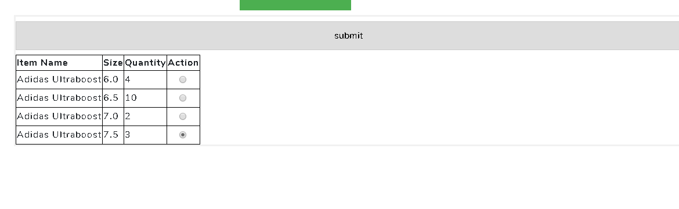

After: the record has deleted

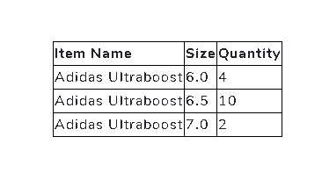

Code:

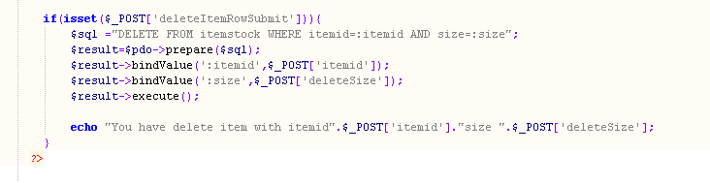

## Insert

After a customer has confirm the check out process. The customer details and item details stored in session will be retrieved and prepared in the sql The purchase record will be inserted into the database and the item details in session will be unset.

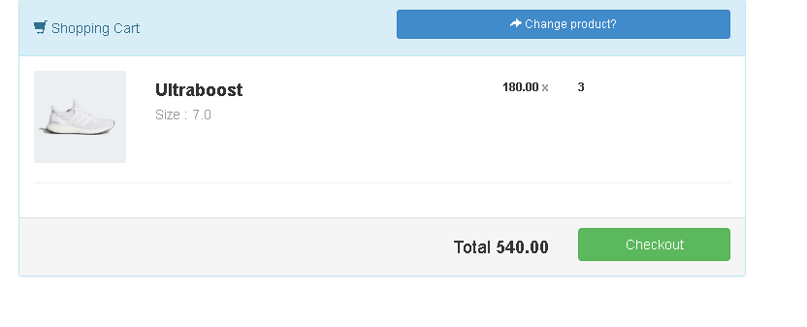

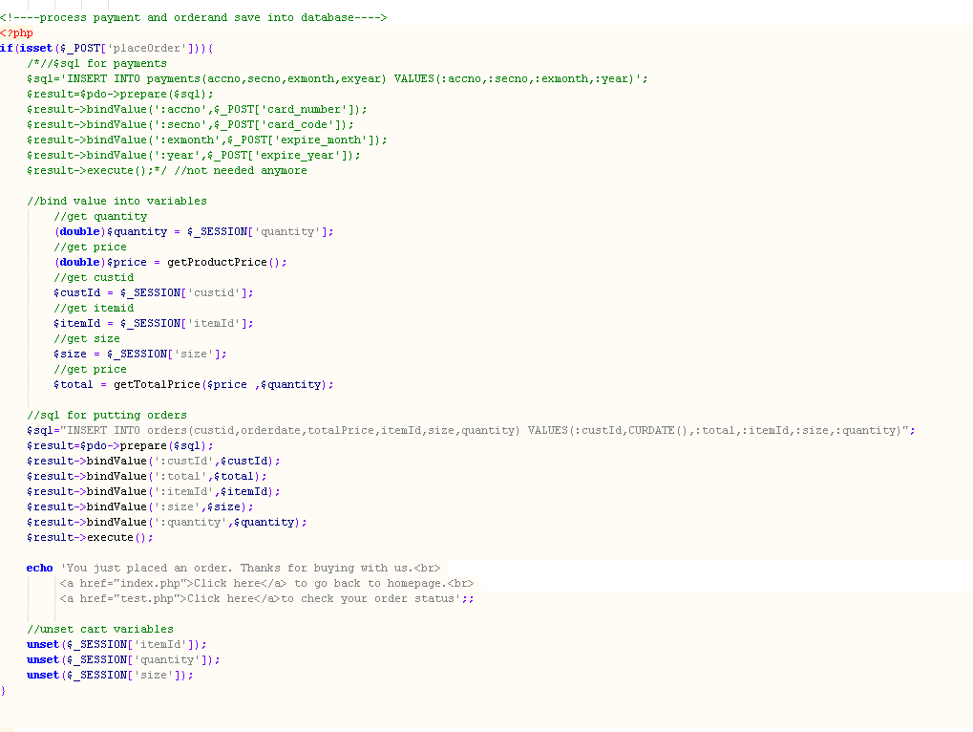

# View of database

## Customer:

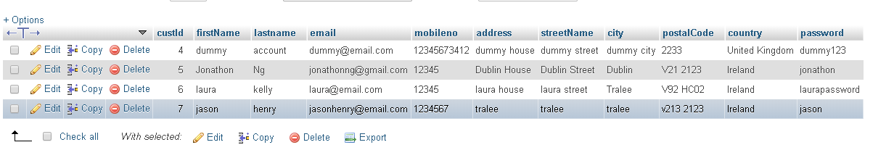

## Item:

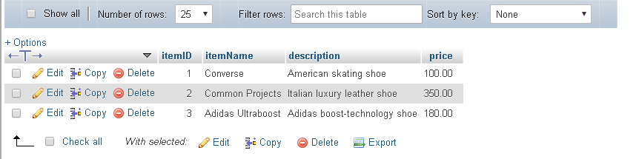

## Itemstock:

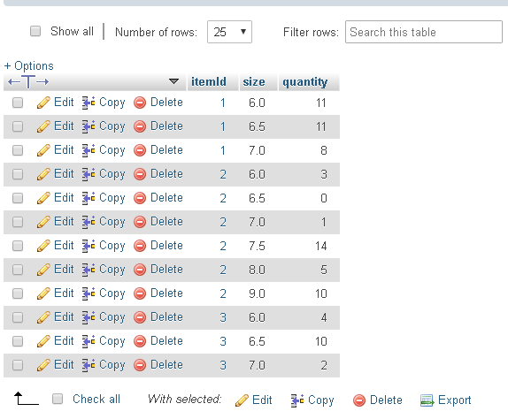

## Orders:

